Install JDK, write a simple “Hello World” or similar java program, compilation, debugging, executing using java compiler and interpreter.

Setp1:-

Download JDK 1.6 [ whatever the version you want, its 1.6 the time i writing this article ] from www.oracle.com / any sharing sites, its just about 50 – 60 Mb in size.



Setp2:-

Now just double click on this application and just follow the bellow steps…

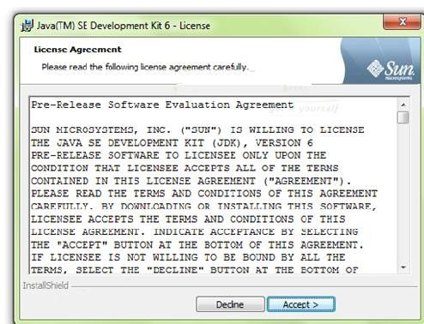

Click on Accept >

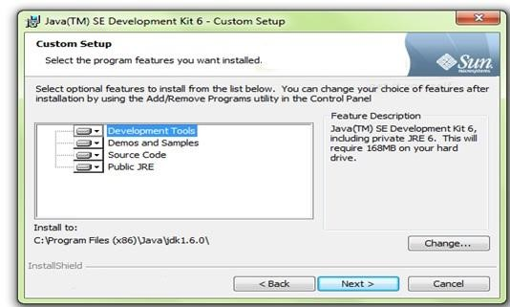

Click on Next >

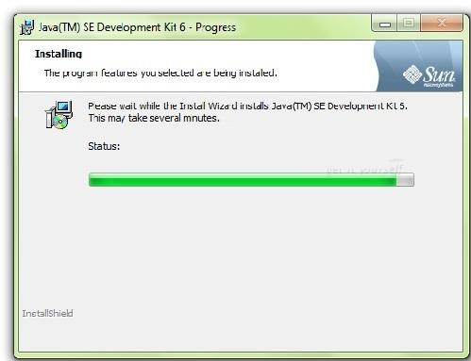

Let is install >

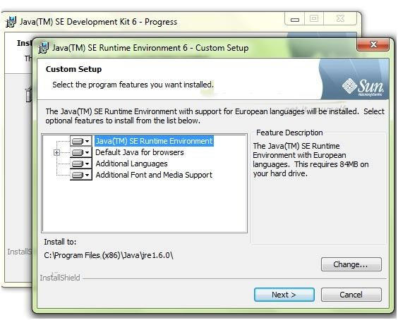

Now you will get one new window with title SE Runtime Environment 6, which is nothing but JRE, JDK needs JRE to be install first, so click Next

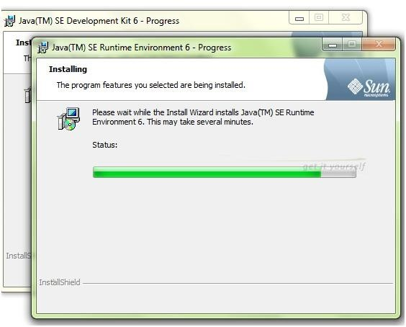

Then finally it will show you one window with Finish button just click on that, and that’s it, let us see the class path settings….

Its simple mates, just right click on My Computer Icon then choose Advanced system settings.. click on that Advanced system settings then it will shows like..

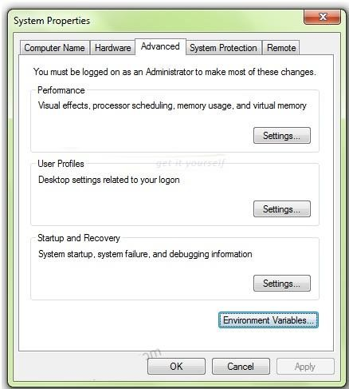

Now just click on Environment Variables button at bottom-right then…

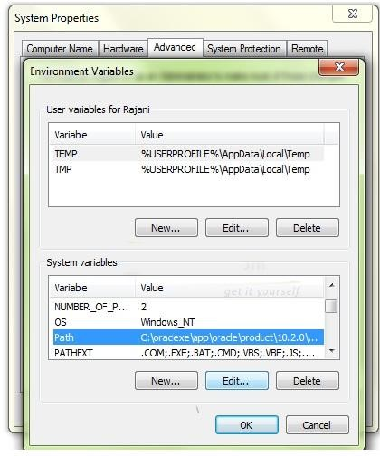

Then select path, and click on Edit button…. Now there, just append your bin folder path of jdk folder, it is like…

c:\Program Files (x86)\Java\jdk1.0.6\bin;

# Compiling Java Programs

1. Open the Notepad text editor Start > All Programs > Accessories > Notepad and type the following program into it: class HelloWorld { public static void main(String[] args) {

}

System.out.println("Hello World!");

}

1. Save the program to the C:\ drive in a file named HelloWorld.java. Make sure to select "All Files" in the Type field of the Save As dialog box.
2. To compile the program, open the Dos Prompt Start > All Programs

>

Accessories > Command Prompt and type:

cd\

javac HelloWorld.java

If you don't get any errors then everything went well. If you get errors, check firstly that you saved the program on the C:\ drive and that it is named HelloWorld.java.

# Running Java Programs

1. To run the program, type:
2. java HelloWorld
3. you should get the following output: Hello World!

# Common Errors and Solutions

1. Exception in thread "main" java.lang.NoSuchMethodError: main You must define a main method as: public static void main(String[] args) {...}
2. HelloWorld.java:3: illegal character: \8220 System.out.println(öHelloWorld!ö);

Do not type your code in a word processor application that uses smart quotes!!

1. HelloWorld.class Exception in thread "main" java.lang.NoClassDefFoundError: HelloWorld/class

The correct way to call a program is java HelloWorld without the ".java" or ".class"